L Series Led Street Light

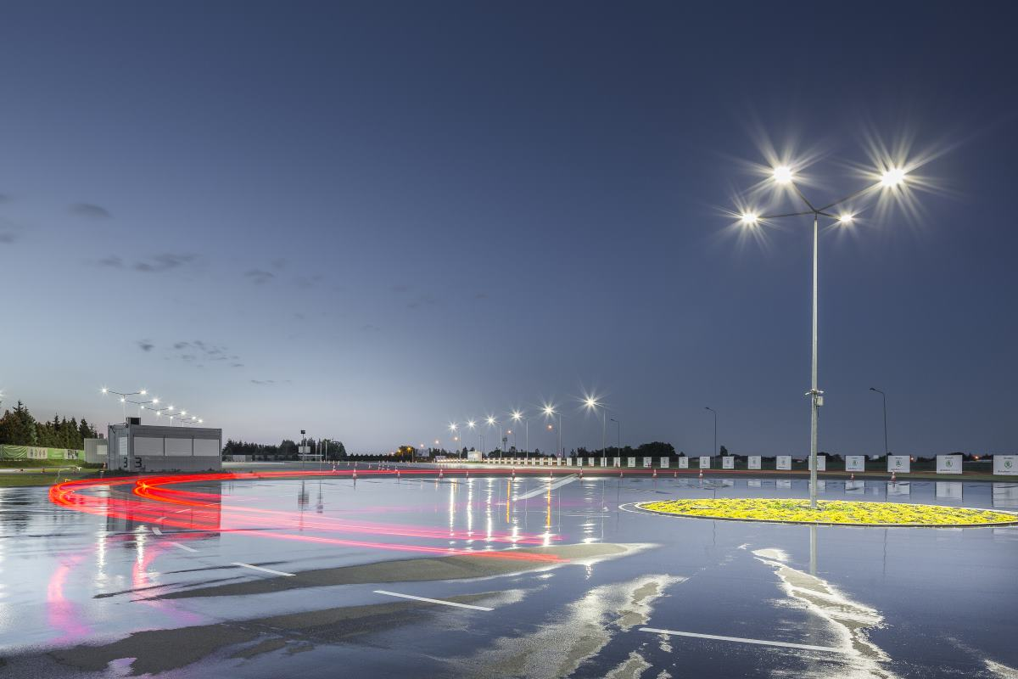

High-quality aluminum alloy, with integrated shell, high hardness, not easy to break, good heat dissipation, greatly improving service life.
The lamp body is completely sealed and work in thunder and rain.
High-quality high-brightness LED light source, high luminous efficiency, high color rendering, no radiation
pollution, long service life.
No EMI, low harmonic distortion (THD), through the CE, ROSS, FCC, SAA, RCM certification requirements.
Working under the ambient temperature -30°to 55°

LED Source: Philips 3030/5050 LED
Overview
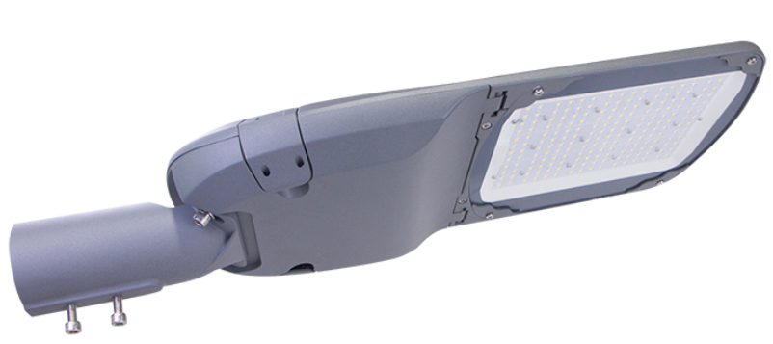
Input Vol: AC100-277V
SPD:10KV
CRI: >75Ra
IP Rate: IP66
Warranty: 5 years
Beam angle: Type 2 / Type 3
Model | Housing Dimensions(mm) | Housing Net weight | Suitable for Wattage
L series -Mini | 200x555x105 | 2.5KGS | 30w,40w,50w,60w
L series -Medi | 233x615x100 | 3.1KGS | 75w,80w,100w
L series -Large | 260x675x100 | 3.8KGS | 120w,150w
L series -Max | 310x726x113 | 5.1KGS | 180w,200w240w

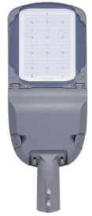
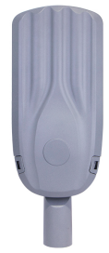

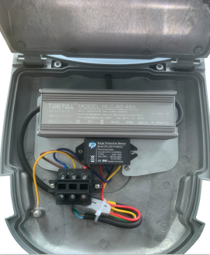
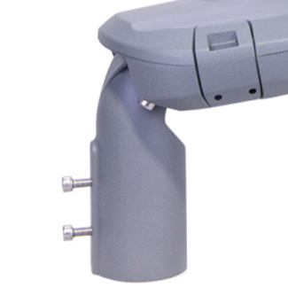
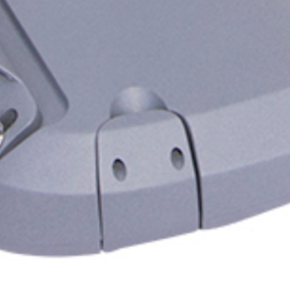
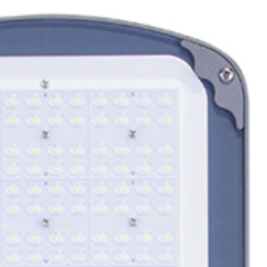

Buckle:
Easy to disassemble
Mounting arm:
0-90° adjustable

PMMA Lens:
PC+Glasses

Power off switch:
Safe for installing and maintenance

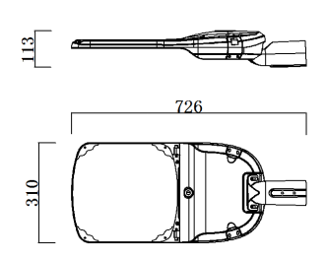
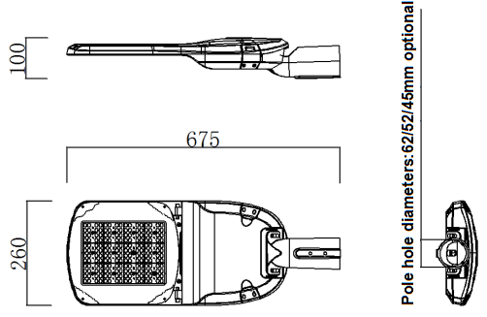
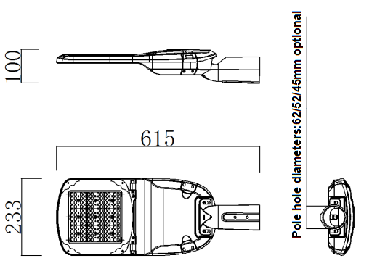
Production dimensions
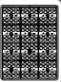
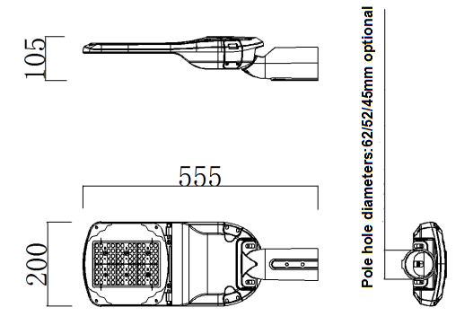

50W 100W 150W 200W

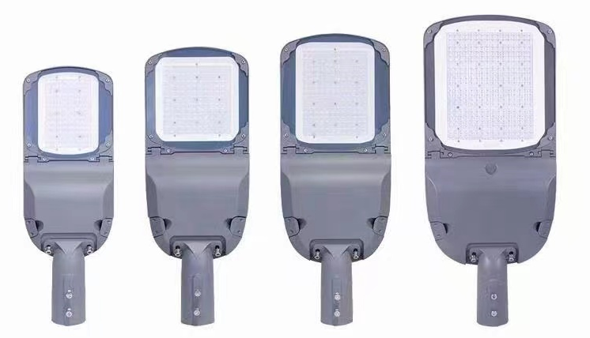

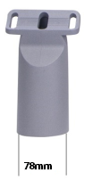
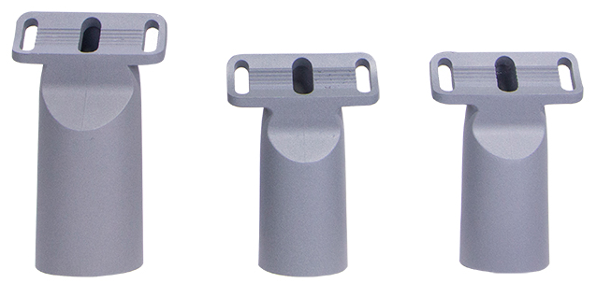

45mm 52mm 62mm
Products Characteristics-1

Model： | FL-LSH50W-L01 | FL-LSH100W-L02 | FL-LSH150W-L03 | FL-LSH200W-L04
Wattages: | 30w/40W/50W/60W | 70W/80W/100W | 120W/150W/160W | 180W/200W/240W
Led Source: | Philips-3030LED | Philips-3030LED | Philips-3030LED | Philips-3030LED
Led Qnty: | 96pcs | 144pcs | 192pcs | 288pcs
Working voltage： | AC100-277V | AC100-277V | AC100-277V | AC100-277V
Driver | Inventronics / Meanwell | Inventronics / Meanwell | Inventronics / Meanwell | Inventronics / Meanwell
Beam angle: | Type 2/3 | Type 2/3 | Type 2/3 | Type 2/3
Lumen efficiency： | 120-130lm/w | 120-130lm/w | 120-130lm/w | 120-130lm/w
Power Factor: | >0.95 | >0.95 | >0.95 | >0.95
Correlated Color Temperature： | 3000K-6500K | 3000K-6500K | 3000K-6500K | 3000K-6500K
Color rendering index： | ≥70 | ≥70 | ≥70 | ≥70
IP Rating: | IP66 | IP66 | IP66 | IP66
Material | Aluminum Alloy | Aluminum Alloy | Aluminum Alloy | Aluminum Alloy
Weight: | 2.8kgs | 3.9kgs | 4.8kgs | 6.2kgs
Warranty | 5 years | 5 years | 5 years | 5 years

Products Electrical Paraments

 |  |  |  | Nominal  flux (lm) (*) | Power consumption  (W) | Nominal  efficacy  (lm/W) | Luminaire  output flu(lm) | Luminaire  efficacy  (lm/W) | Photometry
Lamp | 3030 LEDs | Current  (mA) | Line Current  (A) | (A) Typical | Typical | Typical | Typical | Typical | KingBrite T3
MINI | 96 | 770 | 0.14 | 4680 | 30W | 156 | 3840 | 128 | KingBrite T3
MINI | 96 | 1000 | 0.19 | 6080 | 40W | 152 | 5000 | 125 | KingBrite T3
MINI | 96 | 1300 | 0.23 | 7300 | 50W | 146 | 6100 | 122 | KingBrite T3
MINI | 96 | 1550 | 0.27 | 7920 | 60W | 132 | 6480 | 108 | KingBrite T3
MEDI | 144 | 1800 | 0.32 | 10850 | 70W | 155 | 8890 | 127 | KingBrite T3
MEDI | 144 | 2050 | 0.36 | 12080 | 80W | 151 | 9920 | 124 | KingBrite T3
MEDI | 144 | 2550 | 0.45 | 14800 | 100W | 148 | 12100 | 121 | KingBrite T3
LARGE | 192 | 3050 | 0.54 | 18720 | 120W | 156 | 15360 | 128 | KingBrite T3
LARGE | 192 | 3800 | 0.68 | 22800 | 150W | 152 | 18750 | 125 | KingBrite T3
LARGE | 192 | 4050 | 0.72 | 23680 | 160W | 148 | 19360 | 121 | KingBrite T3
MAX | 288 | 4550 | 0.82 | 27900 | 180W | 155 | 22860 | 127 | KingBrite T3
MAX | 288 | 5000 | 0.91 | 30200 | 200W | 151 | 24800 | 124 | KingBrite T3
MAX | 288 | 6000 | 1.09 | 29600 | 240W | 148 | 29040 | 121 | KingBrite T3

Tolerance on LED flux is ± 7% and on total luminaire power ± 5%
(*) The nominal flux is an indicative LED flux @ Ts 85°C based on LED manufacturer’s data. The real flux output of the luminaire depends on
environmental conditions (e.g. temperature and pollution) and the optical efficiency of luminaire. The type of LED used is subject to change
due to the ongoing rapid progress taking place in LED technology

Products Characteristics-2

Model： | FL-LSH50W-L01 | FL-LSH100W-L02 | FL-LSH150W-L03 | FL-LSH200W-L04
Wattages: | 30W/40W/50W/60 | 70W/80W/100W | 120W/150W/160W | 180W/200W/240W
Led Source: | Philips-5050LED | Philips-5050LED | Philips-5050LED | Philips-5050LED
Led Qnty: | 24pcs/36pcs | 54pcs | 72pcs | 120pcs
Working voltage： | AC100-277V | AC100-277V | AC100-277V | AC100-277V
Driver | Meanwell/inventronics | Meanwell/inventronics | Meanwell/inventronics | Meanwell/inventronics
Beam angle: | Type 2/3 | Type 2/3 | Type 2/3 | Type 2/3
Lumen： | 7500lm | 15000lm | 22500lm | 30000lm
Power Factor: | >0.95 | >0.95 | >0.95 | >0.95
Correlated Color Temperature： | 3000K-6500K | 3000K-6500K | 3000K-6500K | 3000K-6500K
Color rendering index： | ≥70 | ≥70 | ≥70 | ≥70
IP Rating: | IP66 | IP66 | IP66 | IP66
Material | Aluminum Alloy | Aluminum Alloy | Aluminum Alloy | Aluminum Alloy
Weight: | 2.8kgs | 3.9kgs | 4.8kgs | 6.2kgs
Warranty | 5 years | 5 years | 5 years | 5 years

Products Electrical Paraments

 |  |  |  | Nominal  flux (lm) (*) | Power consumption  (W) | Nominal  efficacy  (lm/W) | Luminaire  output flu(lm) | Luminaire  efficacy  (lm/W) | Photometry
Lamp | 5050 LEDs | Current  (mA) | Line Current  (A) | (A) Typical | Typical | Typical | Typical | Typical | KingBrite T3
MINI | 24 | 600 | 0.14 | 5730 | 30W | 191 | 4680 | 156 | KingBrite T3
MINI | 24 | 800 | 0.19 | 7520 | 40W | 188 | 6160 | 154 | KingBrite T3
MINI | 24 | 1000 | 0.23 | 8900 | 50W | 178 | 7300 | 146 | KingBrite T3
MINI | 36 | 1200 | 0.27 | 11460 | 60W | 191 | 9420 | 157 | KingBrite T3
MEDI | 54 | 1400 | 0.32 | 13510 | 70W | 193 | 11060 | 158 | KingBrite T3
MEDI | 54 | 1600 | 0.36 | 15040 | 80W | 188 | 12320 | 154 | KingBrite T3
MEDI | 54 | 2000 | 0.45 | 18500 | 100W | 185 | 15200 | 152 | KingBrite T3
LARGE | 72 | 2400 | 0.54 | 22920 | 120W | 191 | 18840 | 157 | KingBrite T3
LARGE | 72 | 3000 | 0.68 | 28500 | 150W | 190 | 23400 | 156 | KingBrite T3
LARGE | 72 | 3200 | 0.72 | 29440 | 160W | 184 | 24160 | 151 | KingBrite T3
MAX | 108 | 3600 | 0.82 | 33840 | 180W | 188 | 27720 | 154 | KingBrite T3
MAX | 108 | 4000 | 0.91 | 37000 | 200W | 185 | 30400 | 152 | KingBrite T3
MAX | 108 | 4800 | 1.09 | 44160 | 240W | 184 | 36240 | 151 | KingBrite T3

Tolerance on LED flux is ± 7% and on total luminaire power ± 5%
(*) The nominal flux is an indicative LED flux @ Ts 85°C based on LED manufacturer’s data. The real flux output of the luminaire depends on
environmental conditions (e.g. temperature and pollution) and the optical efficiency of luminaire. The type of LED used is subject to change
due to the ongoing rapid progress taking place in LED technology

Photometric distribution

Type II Type III

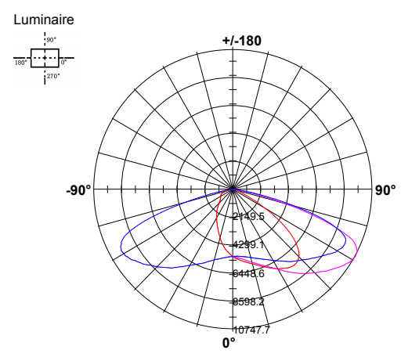
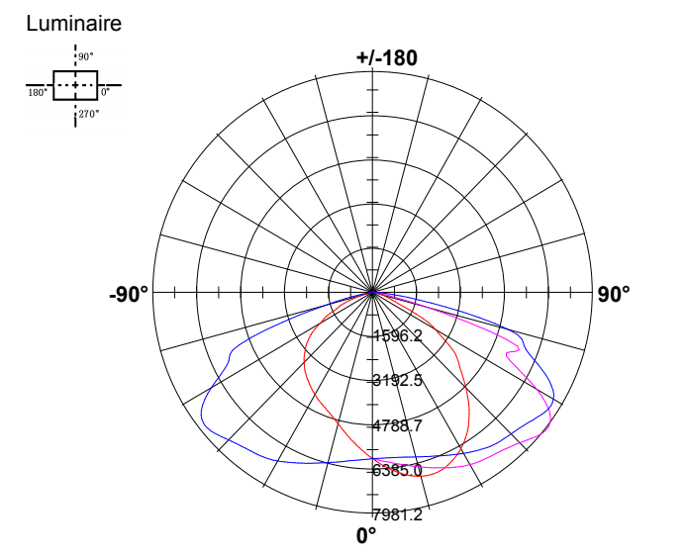

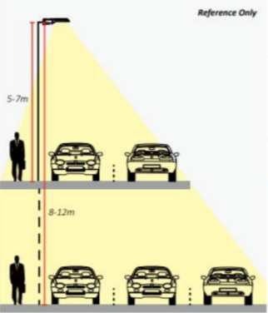

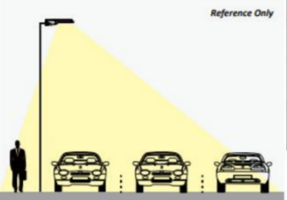

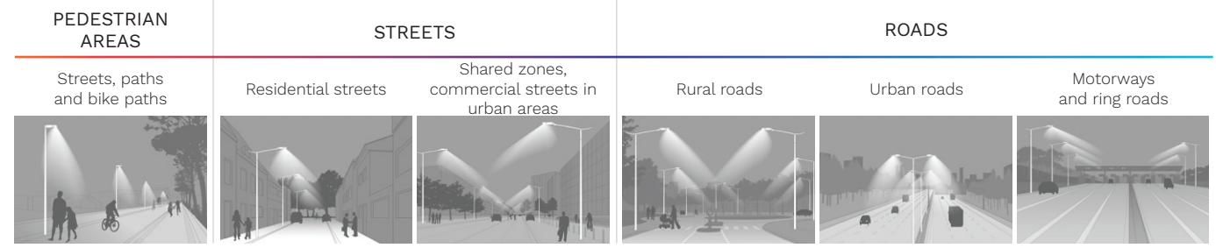

Dissamble illustration

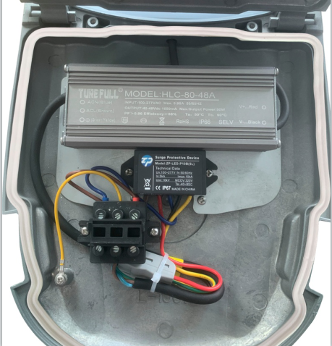
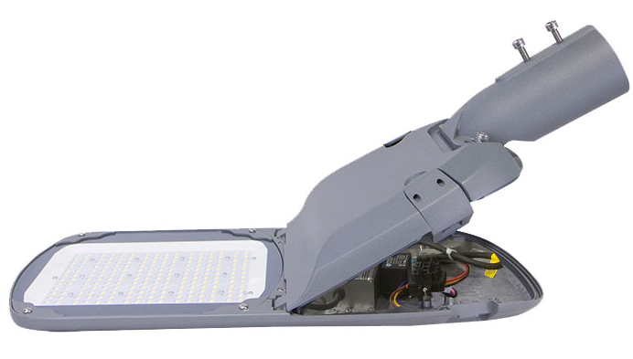
LED Driver
SPD 10KV/20kv

Disconnection protection
Rubber gasket

Earth line

Aluminum alloy housing

Spigots:45/52/62mm optional
LED Beads

Tempered glass
Acrylic PMMA Lens
Driver box
Buckle

White nano reflector

Intelligent Dimming Control
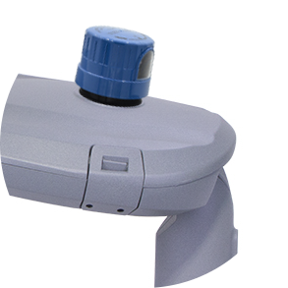
The dimming photo controller JL-241/242/243 series is applicable to control any independent LED home/street lighting automatically in accordance with the ambient natural lighting level. This product is designed with microprocessor circuits with IR-filtered silicone sensor, a heavy duty surge arrester (MOV) is provided to protect the lamp from inrush current as well as impulse by lightening. Further, a preset 10 seconds time-delay prevents excessive operation due to spotlight or lightning during the night time. A heavy duty relay supports the work life of over 15,000 cycles, and offers extra long work life when an optional metal Armor is applied together. This product provides twist lock terminals and signal contacts meeting the requirements of ANSI C136.41-2013, as well as being listed by UL under the Standard for Plug-In, Locking Type Photo controls for Use with Area Lighting ANSI/UL773.

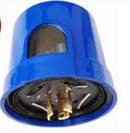

Constant On/Off Dimming Standard program for LED output keeping the field lit with constant lighting level, in accordance with the natural sunlight level detected. When the natural lighting is higher than 110% of the rated level,live line will be disconnected to keep LED fixture as zero consumption Available with JL-241C, JL-242C and JL-243C.
Items | Function (0~10V dimming) | Items | Function (DAU dimming)
JL-241C | Constant illumination ( Bright in the evening, off in the morning ) | JL-251C | Constant illumination ( Bright in the evening, off in the morning )
JL-242C | Constant illumination,  Midnight low brightness | JL-252C | Constant illumination,  Midnight low brightness
JL-243C | Constant illumination,  Midnight low brightness,  Optical decay compensation | JL-253C | Constant illumination,  Midnight low brightness,  Optical decay compensation
JL-244C | Constant illumination,  Midnight low brightness,  Optical decay compensation,  Mobile APP Control | JL-254C | Constant illumination,  Midnight low brightness,  Optical decay compensation,  Mobile APP Control

Breathing valve Optional：
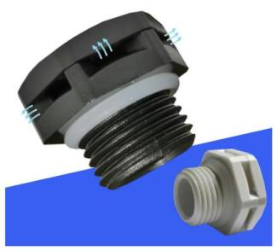
Waterproof
Air circulation
Pressure balance

Driver brand optional：
Turefull
Meanwell
Philips
Inventronics






SPD optional：
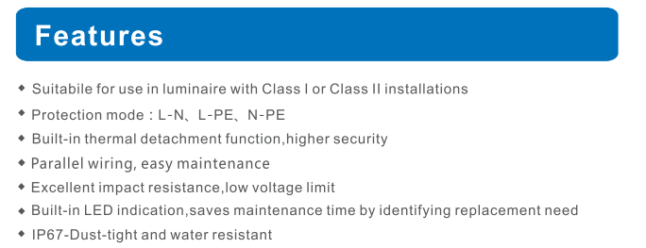
SPD 10KV
SPD 20KV

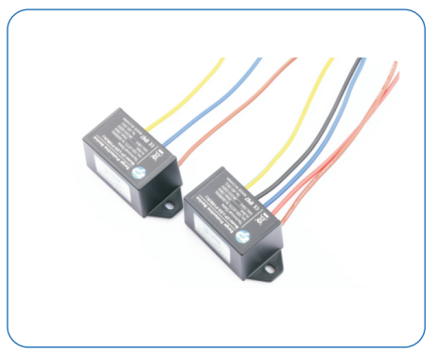

City Smart lighting Control system

Zigbee wireless system
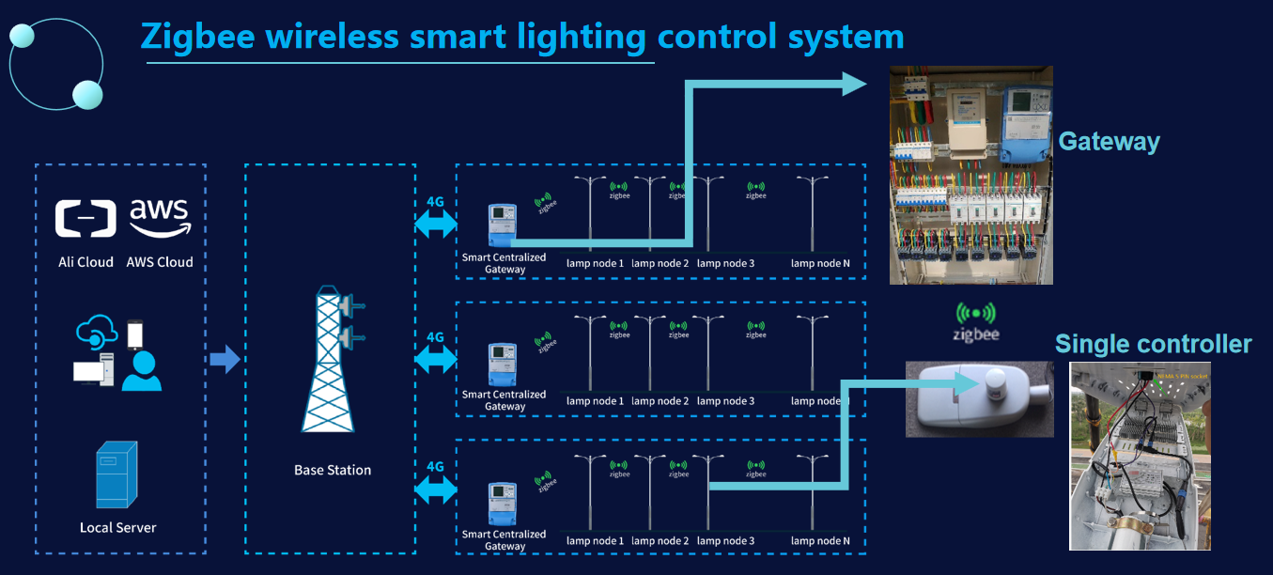

LoRa wireless system
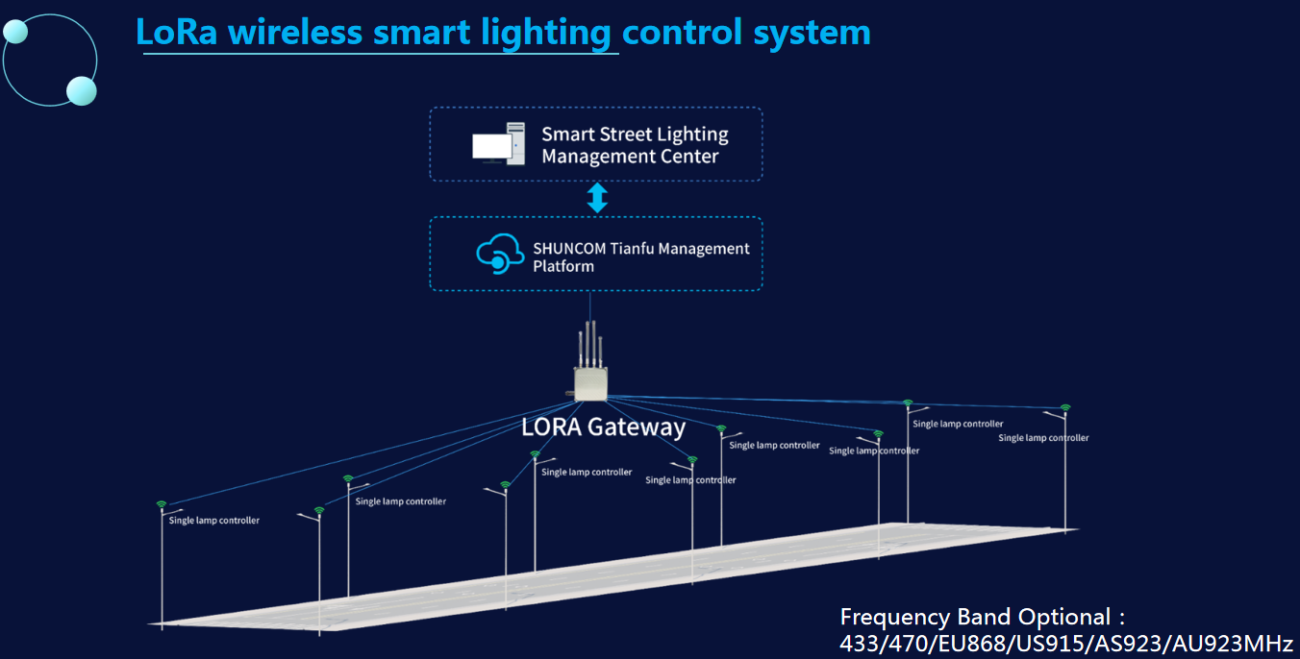

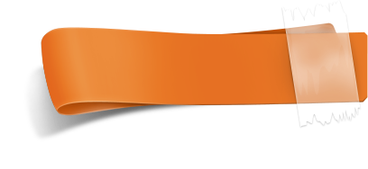
Installation Instructions

Attention:

- Be sure disconnect power before installing, don’t construction with electricity.
- Product working voltage is AC100~277V,50/60Hz，Please do not exceed the working voltage range.
- Input product line, brown is L ,blue is N, yellow-green is GND.
- Be sure wiring is closed and prevent leakage, when installing.
- The lamp can not be used in violation of any fire regulations.
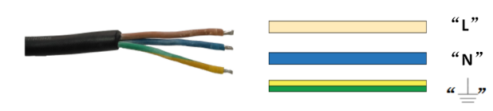

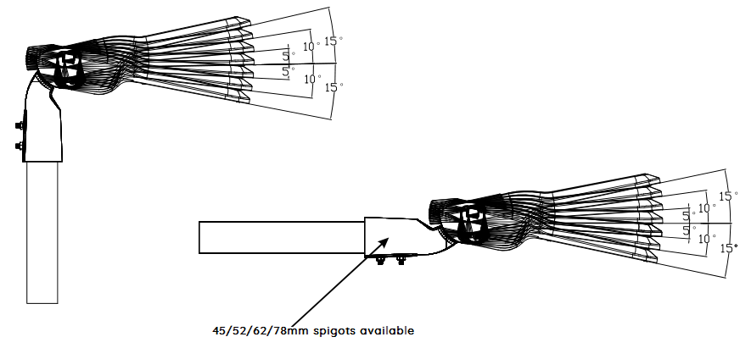
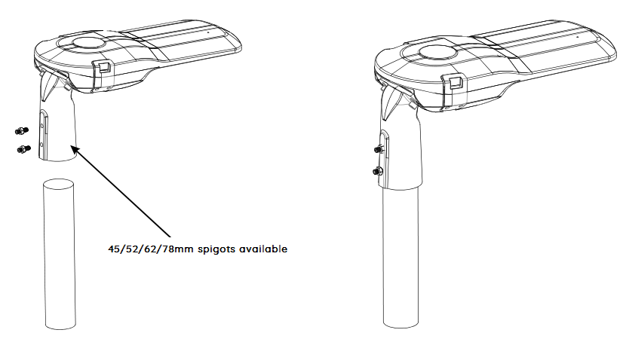



Package

Item | FL-LSP50W-L01 | FL-LSP100W-L02 | FL-LSP150W-L03 | FL-LSP200W-L04
Package Qty | 1 PC | 1 PC | 1 PC | 1 PC
GW | 3.7 KGS | 4.8KGS | 5.8 KGS | 7.2KGS
Cartons (mm) | 630*230*150MM | 670*280*150MM | 730*300*150MM | 760*350*150MM

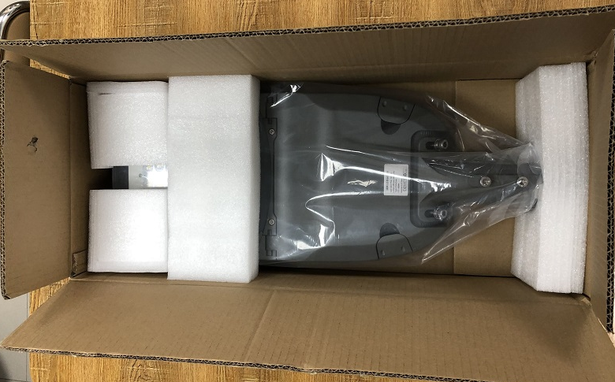
Warranty Policy

All products are under 5-year warranty since the date of luminaires were deliver to you.

1. Under warranty terms,if products are broken down under normal usage within warranty period, company will provide new lamp for instead of or provide FREE Maintenance service base on the proof-documents and invoice (copy) of the failed products.
2. company will not provide paid maintenance service under following conditions even within warranty period.
a )Failure or damage caused by force majeure.
b) Failure or damage caused by transportation or unloading
c) Failure or damage caused by incorrectly usage or fail to comply with the manual and caution
d) Failure or damage caused by demolition, repair or alternation without our authorization.
3. company always reserves the right for final explanation of aforesaid terms

